**Game Design Studio Two**

**“Mowdown”**

**Team Four**

Report for Sprint Three

07 / SEP / 2015 – 20 / SEP / 2015

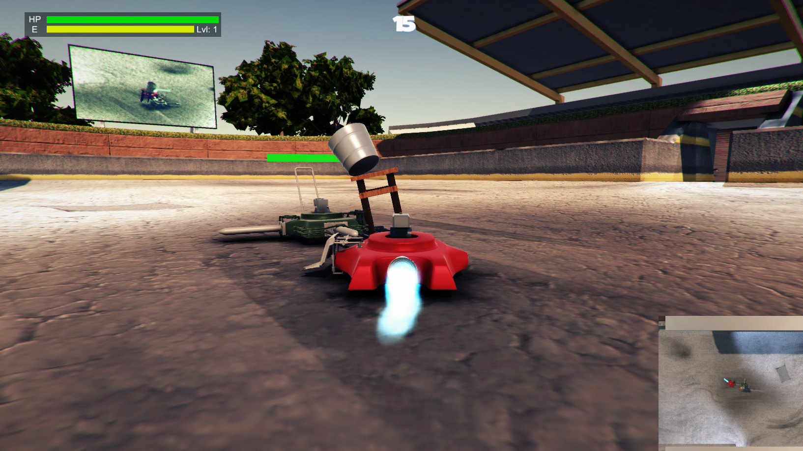

**Team Members:**

Matthew Carver –12028130

Deinyon Davies – 11688025

Robert McClelland –11743693

Dinh Bao Anh (Brendan) Vo – 11437237

The most honoured Master of the Scrum,SirJesse Walker – 11729631

**OVERVIEW**

*Mowdown* is a ‘Demolition Derby’ or ‘Battle Bots’ style videogame, created by (in ascending alphanumeric order) Matthew Carver, Deinyon Davies, Robert McClelland, Dinh Bao Ahn (Brendan) Vo, and Jesse Walker.

Players customize one of several domestic **lawnmowers** by means of attaching defence appliances and weapons that have been unlocked and purchased by the player by means of in-game experience points and currency. Players compete against at least one autonomous opponent – a strategically formed battle-mower – as if both are controlled via Remote Control (R.C.).

Sprint Three sports several new features, bug fixes and enhancements, including (but not limited to): Sound effects, Top-Down Camera (‘P’ to Toggle), Particle effects for certain attachments, Level Hazards, a new level design, improved damage mechanics, attachments including a booster, an obstacle-avoidance camera, attachment socketing system for the enemy, and somewhat improved Artificial Intelligence.

**SPRINT PLAN AND EXECUTION**

Sprint Three of Project Mowdown set out to implement fifteen discrete new features including (but not limited to): bug-fixes, level design, improved Artificial Intelligence, improved User Interface, Sound effects, Top-Down Camera mode, vehicle modelling and vehicle attachment modelling and implementation. These sixteen task items were identified in the initial Sprint Meeting.

As of the preliminary Sprint Meeting, the Sprint Log proposed a **total** **estimated** investment of **2,260 minutes** – 250 minutes less than the estimated investment for Sprint Two - with estimated **median** task duration of **50 minutes**. The sprint would optimistically be completed in 1,450 minutes.

During the execution of the scrum, 2 critical and prerequisite tasks became apparent, which were completed and appended to the Sprint Log when necessary. The auxiliary tasks assumed an additional estimated duration of 80 minutes, expanding the **total** **estimated** sprint workload to **2,340** **minutes** (39 hours).

Two tasks with an indeterminate length were added to the sprint and assigned to Matthew and Jesse. These tasks were the creation of models, and the development of attachments respectively. These tasks were implemented as several of our testers expressed a want for more attachments, however as these attachment ideas were not thought of yet it was not possible to assign an estimate time to the creation of the models.

At Sprint finalisation, the Sprint Log totalled 30 expected and unexpected tasks. The team observed a **total** **logged** **workload** of **1,745 minutes** (~29 hours). 6 tasks stood incomplete or uninitiated at the time of sprint closure.

**SCRUM MEETING LOGS**

**07 / SEP / 2015**

4:30pm – 6:00pm

**Location**: UTS Building 11, Game Design Studio Laboratory

**Members present**: Brendan, Deinyon, Jesse, Matthew, Robert

The team identified backlog items and discussed time estimates.

**14 / SEP / 2015**

4:30pm – 6:00pm

**Location**: UTS Building 11, Game Design Studio Laboratory

**Members present**: Deinyon, Jesse, Matthew, Robert

The team discussed and worked on the implementation of the flipper activation animation.

**17 / SEP / 2015**

7:00pm – 9:00pm

**Location:** Online Group Discussion

**Members present:** Deinyon, Jesse, Robert

The team discussed bugs with the most recent version pertaining to the sockets and the inability to add attachments to the player. Jesse had recently completed work that reworked this system, and once implemented fixed the bugs.

The team discussed a possible fix for the lighting bug with the floor in the first battle scene. The attempted fix was available for unity 5.2 so Deinyon upgraded the project to the new version. The game could still be opened on unity versions 5.1.2.f (such as the UTS computers) so it was decided this would be fine. Unfortunately this update broke the analytics.

The team discussed whether or not the analytics should be re implemented, the process being significantly different from the process in unity 5.1.2.f. It was decided that the analytics was not being used, and the information provided was not useful for the current state of the game. This meant game analytics was removed as a feature of the game.

**20 / SEP / 2015**

**Location**: Online Group Discussion

**Members present**: Deinyon, Jesse, Robert

Discussed and implemented the desired particle effect for the booster attachment. See the following figure for the desired effect:

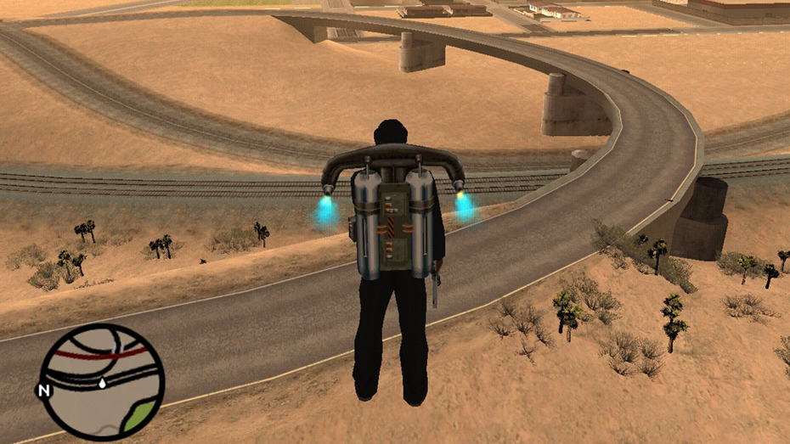

**BURNDOWN CHART**

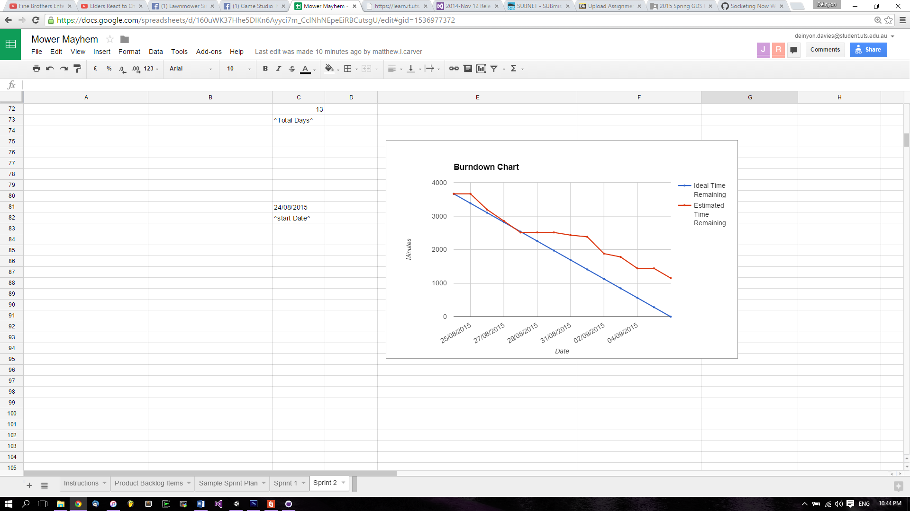

**REFLECTION**

Despite having less estimated time required for this sprint the state of the project was in disarray at the end of sprint two due to a problem with ‘*github’* commits. Repairing the damage and restoring all functions that were ‘completed’ in sprint two took the first week, considerably longer than the estimated time; Once the project was deemed ‘repaired’ on the 16th the team was able to resume normal work. The Burndown Chart illustrates that very little work was done over the course of the first week and that much of the work was completed in the last few days coming up to the end of the sprint. Much of the work of sprint three was completed on the final day of the sprint. This was due to several other classes having assignments due during this time. It will be important to remember other classes when choosing how many use cases will be assigned to each sprint, as the team had difficulty completing all the work assigned.

**SPECIAL CIRCUMSTANCES**

N/A

**VERSION CONTROL COMMIT LOG**

commit a12b63df626fab68bd7616293d61678bd48d913d

Merge: af31af3 f910d45

Author: Deinyon Davies <deinyond@gmail.com>

Date: Sun Sep 6 22:24:22 2015 +1000

Merge branch 'master' of https://github.com/ddoodm/GameStudioTwo

commit af31af374be08e4082e10ab09228e3dd943d9e76

Author: Deinyon Davies <deinyond@gmail.com>

Date: Sun Sep 6 22:22:20 2015 +1000

Initial Commit of Sprint Two Documentation

commit f910d456a317f142d2da02f599625fae28abf725

Author: JesseWalker11729631 <11729631@student.uts.edu.au>

Date: Sun Sep 6 21:02:25 2015 +1000

Socketing Now Works in Garage

commit e0114cdd994d36a70993bec025cf24217799896e

Author: Deinyon Davies <deinyond@gmail.com>

Date: Sun Sep 6 19:29:34 2015 +1000

Fixed disappearing robot bug

commit c5fcf1b046d4fe65160ef786c528802ada75cccb

Author: JesseWalker11729631 <11729631@student.uts.edu.au>

Date: Sun Sep 6 16:56:49 2015 +1000

Can Spawn Handle On Back Socket

commit 8756fd26b75ddd2467ed2f0acb21410586a34b05

Merge: 8e7df5e 8c51625

Author: Deinyon Davies <deinyond@gmail.com>

Date: Sun Sep 6 11:54:15 2015 +1000

Merge branch 'master' of https://github.com/ddoodm/GameStudioTwo

commit 8e7df5e15c59789e42513f6dbf5393ef0c582bfb

Author: Deinyon Davies <deinyond@gmail.com>

Date: Sun Sep 6 11:52:28 2015 +1000

Fixed terrible AI bugs

commit 8c51625c2bdc875ddcc6d8061143d481b5522974

Author: JesseWalker11729631 <11729631@student.uts.edu.au>

Date: Sun Sep 6 02:12:01 2015 +1000

Sockets Added(No Functionality), Various Store UI Tweaks and Functionality Updates

commit c9b4cd320de5c332d91e3f572d39ed110a45adb4

Author: robafett <ram_95@msn.com>

Date: Fri Sep 4 22:42:12 2015 +1000

More tests

commit cc98b346a7032b772eaee8f9637a7d9a4a5e6806

Author: robafett <ram_95@msn.com>

Date: Thu Sep 3 18:48:51 2015 +1000

Fixed up controller support, added armor back onto bot doesn't look gr8 but works

commit e12ebb0fa1c15f36b37a1f436dcafd1ce4081ab2

Author: Matthew Carver <matthew_carver@live.com>

Date: Thu Sep 3 16:28:46 2015 +1000

Added the new mower and assets

Created subfolders to organise the models but didnt move them because I

am unsure if it will ruin any code you guys have

commit 10fcbd71ab3a8e4fce6fa645d35d93824de4835f

Author: Deinyon Davies <deinyond@gmail.com>

Date: Thu Sep 3 15:42:30 2015 +1000

Lighting Update & AI Fixes (no more wall-ramming!)

Should have (hopefully) somewhat fixed the bug where the bot would

become stuck to walls by not reversing properly.

Also made some lighting / material changes.

commit 46daa7b6c7598f60235f274325a4227823b6f3db

Author: Deinyon Davies <deinyond@gmail.com>

Date: Wed Sep 2 21:35:39 2015 +1000

Improved Warehouse Scene for More Room

commit 2273bd20d796b0f89e11478b69c5b0b64bddd396

Author: robafett <ram_95@msn.com>

Date: Wed Sep 2 20:36:13 2015 +1000

Fixed Mass of flipper being added to player (Map Scene 1)

commit 6b222ff7b225a508bfafe54e6e4fe98000edf956

Author: robafett <ram_95@msn.com>

Date: Wed Sep 2 20:17:44 2015 +1000

Rob's playtests

commit 71c53147b780437f64ab0a6162cb0f6c4a2cbb8b

Author: Deinyon Davies <deinyond@gmail.com>

Date: Wed Sep 2 19:41:38 2015 +1000

Attempted to Fix Wheel Bugs

commit 9842dbee44f24eb00a5d6d815ed19281b316d08d

Author: Deinyon Davies <deinyond@gmail.com>

Date: Wed Sep 2 13:27:10 2015 +1000

Implemented Wheel Model Display

commit 6a2410bb3a1a3d5deef028c82ab80d08afc48393

Author: robafett <ram_95@msn.com>

Date: Tue Sep 1 21:42:11 2015 +1000

Super Boring UI for Color Selection

commit 1797743f60393e405f3edc118efc04fe4307aeab

Author: robafett <ram_95@msn.com>

Date: Tue Sep 1 21:12:53 2015 +1000

Flip the player back over with the flipper!

commit 649e5e1dcf7ba5ad5860f4f30f9e9c425fed64ca

Author: robafett <ram_95@msn.com>

Date: Tue Sep 1 18:26:19 2015 +1000

Unity Analytics wooo

commit f528963a7fda8f100d3cf84996b1e7609948e003

Author: robafett <ram_95@msn.com>

Date: Tue Sep 1 17:45:08 2015 +1000

key to activate now depends on the socket

commit 8258672010e6b5e96030a1b6c5092c5443fc6f29

Author: Deinyon Davies <deinyond@gmail.com>

Date: Tue Sep 1 16:22:12 2015 +1000

Disallow flipping until flipper has retracted

commit 095bca3e8fd7b19d0e98853fda72acb22f1aebc2

Author: Deinyon Davies <deinyond@gmail.com>

Date: Tue Sep 1 15:53:45 2015 +1000

Improved Flipper Code

commit 45d4699fb818c5f17aee9888c91da8f63cd86b4a

Author: robafett <ram_95@msn.com>

Date: Tue Sep 1 11:39:19 2015 +1000

Shoddies flipper code ever

commit 99c71297d0366461e04d0059303c5712147e7cc2

Author: Deinyon Davies <deinyond@gmail.com>

Date: Mon Aug 31 16:35:32 2015 +1000

Fix spike bug

commit cc105c2b37f5530abf49fcea5bdb3d9e7aedca9b

Author: JesseWalker11729631 <11729631@student.uts.edu.au>

Date: Mon Aug 31 22:20:04 2015 +1000

Placed flipper on model

commit a6c2bc12c35dc9bda4af85781bc5f8fadf49437b

Author: Deinyon Davies <deinyond@gmail.com>

Date: Mon Aug 31 12:22:55 2015 +1000

Fixed poor ladder collisions

commit bd792f8a4e224ede2a3eba10da0b9b7c6fe8b3af

Author: Deinyon Davies <deinyond@gmail.com>

Date: Mon Aug 31 11:29:40 2015 +1000

Implemented UI in new Battle Scene

commit c1b7708287489653c9a4cef1519b3f792ccc47ac

Author: Deinyon Davies <deinyond@gmail.com>

Date: Sun Aug 30 16:32:56 2015 +1000

Merge fixes for new Obstacle Avoidance Camera

commit 5cda19d462baa5e525e5da27d4bdee383c4db46f

Merge: 99bbfeb f45c721

Author: Deinyon Davies <deinyond@gmail.com>

Date: Sun Aug 30 16:29:20 2015 +1000

Merge branch 'AvoidanceCamera'

commit f45c721bf75a37fee0c61ddb557bc4235a95e3a5

Author: Deinyon Davies <deinyond@gmail.com>

Date: Sat Aug 29 17:42:03 2015 +1000

Improved Camera Obstacle Avoidance

commit 99bbfebffaabc145ab8415944f4ac4bb6af0663f

Author: dinhvo7 <dinhvo7@gmail.com>

Date: Sat Aug 29 03:45:09 2015 +1000

fix miniMap

commit 6b8806ee0e01d71e3d096e05ea9abfd281061275

Merge: 5d79b9a 3df7a97

Author: dinhvo7 <dinhvo7@gmail.com>

Date: Sat Aug 29 03:38:14 2015 +1000

Merge pull request #4 from ddoodm/GameOverScreen

merge gameOver Screen

commit 3df7a979341881001a5c4195c4552a9f231fabed

Author: dinhvo7 <dinhvo7@gmail.com>

Date: Sat Aug 29 03:35:21 2015 +1000

merge gameOver Screen

commit 5d79b9a5321ffdb0725b731bc16793d2f791082e

Merge: 25c73bf 68230a6

Author: dinhvo7 <dinhvo7@gmail.com>

Date: Fri Aug 28 23:59:56 2015 +1000

Merge pull request #3 from ddoodm/minimap

add mini map

commit 68230a68f4593c19d77bb0ab4720dc62d460bd4e

Author: dinhvo7 <dinhvo7@gmail.com>

Date: Fri Aug 28 18:46:29 2015 +1000

add mini map

commit 25c73bfd5608e3186da4aca5e9abf60163c085d6

Author: Matthew Carver <matthew_carver@live.com>

Date: Thu Aug 27 16:18:37 2015 +1000

Flipper added

flipper with correct pivot has been added, starting a new mower next

commit f42eb0bcccbcfe9e1f67c63ab69f151157032ffa

Author: Matthew Carver <matthew_carver@live.com>

Date: Tue Aug 25 22:31:31 2015 +1000

Boost Rocket and 2 Side Braces

Completed this afternoon, no textures just yet. starting on the flipper

next.

commit d56d6d1019966896d881a2fea5dabd77d36a09a6

Author: robafett <ram_95@msn.com>

Date: Thu Aug 27 12:06:21 2015 +1000

Attachment Destruction

commit 49b754ce14592ffafa4f81fdc5d3f16827e3041b

Author: Deinyon Davies <deinyond@gmail.com>

Date: Thu Aug 27 11:31:45 2015 +1000

Fixed player health bug & physics issue

commit ed93082ec490d2cf0f5d56a6ecaad45339428dcf

Author: Deinyon Davies <deinyond@gmail.com>

Date: Thu Aug 27 11:16:25 2015 +1000

Warehouse Scene converted to FBX, fixed physics bugs

Also added some Michael Bay to the Warehouse Scene

commit d461ae021d915656f71499eca6b881e8c77a4232

Author: robafett <ram_95@msn.com>

Date: Thu Aug 27 07:13:07 2015 +1000

Armor mechanics (enemy bot in battle 0 now has armor)

Now if you are hit on the armor you take less damage but the armor has

no damage multiplier.

commit 736da574b286b529142af8f7083732caec329608

Author: Deinyon Davies <deinyond@gmail.com>

Date: Wed Aug 26 22:16:10 2015 +1000

Fixed navigation bug in Warehouse Scene

commit d5b66b50b34b3da29373a020dbd9347efcf442ed

Author: Deinyon Davies <deinyond@gmail.com>

Date: Wed Aug 26 21:44:10 2015 +1000

'Warehouse' Battle Scene (V1), Image Effects on Farm Scene

Are the Farm Scene colour curves too intense / incorrect?

Not sure that the new warehouse models will work for everyone - it's a

Max scene right now.

commit 872b4998417d0037b3e1d62866675c4175220ee9

Author: Deinyon Davies <deinyond@gmail.com>

Date: Tue Aug 25 22:13:57 2015 +1000

Merging uncommitted WIP changes

commit 02ea9a555840a0b850c31777291ca7ac2ea30396

Author: robafett <ram_95@msn.com>

Date: Tue Aug 25 17:51:48 2015 +1000

To be approved strafing controls

commit 9d9d8a7fefced348ae5ae80f5bd1cb5b5ae9b2d2

Author: robafett <ram_95@msn.com>

Date: Tue Aug 25 17:17:17 2015 +1000

Flip Back over time

commit 488292f35b02141e3ff58c9051be3a5950a16122

Author: Deinyon Davies <deinyond@gmail.com>

Date: Tue Aug 25 13:15:30 2015 +1000

Camera avoids static obstacles and floor (plus rough level 1 prototypes)

The new camera controller is not perfect - it can be rather jarring.

Using the Navmesh for camera control possibly is not ideal, but I

couldn't think of any way other than using Raycasts (which turned out to

be very unreliable).

Also includes two very rough Level One prototypes.

commit 9d094f411845787d65d9c95604247dc3eb77b991

Author: Deinyon Davies <deinyond@gmail.com>

Date: Mon Aug 24 12:43:25 2015 +1000

Updated lighting and materials in Store UI

commit 79a1eef4f589e794faa628177e1c5a1a3e829783

Author: Deinyon Davies <deinyond@gmail.com>

Date: Mon Aug 24 11:59:26 2015 +1000

Fixed terrain Z-Buffer & lighting bug, x86-64 build